Intelligent Energy Consumption Analytics for Smart Buildings Using Machine Learning and Business Intelligence

1. Refined Title :
Intelligent Energy Consumption Analytics for Smart Buildings Using Machine Learning and Business Intelligence
2. Problem Statement :
Modern smart buildings generate large volumes of energy consumption data from sensors, smart meters, HVAC systems, lighting systems, and electrical equipment. However, much of this data remains underutilized due to the lack of intelligent analytical systems capable of identifying consumption patterns, detecting energy wastage, and predicting future energy requirements. Traditional monitoring systems provide only basic reports and fail to support proactive energy management. This project develops an end-to-end analytics framework that integrates data preprocessing, machine learning, SQL, and Power BI to optimize energy consumption, improve operational efficiency, and support sustainable building management.
3. Detailed Abstract :
The rapid growth of smart buildings has increased the availability of energy consumption data generated from various sources such as smart meters, HVAC systems, occupancy sensors, lighting systems, and electrical appliances. Despite the availability of this data, many buildings still rely on traditional monitoring approaches that do not provide actionable insights for energy optimization and decision-making.
This project proposes an Intelligent Energy Consumption Analytics for Smart Buildings Using Machine Learning and Business Intelligence framework to transform raw energy consumption data into meaningful insights. The framework utilizes Smart Building Energy Consumption Datasets containing information such as energy usage, temperature, humidity, occupancy levels, appliance consumption, time-based records, and environmental conditions.
The dataset is preprocessed using Python, NumPy, and Pandas by handling missing values, removing duplicates, cleaning data, and performing feature engineering. Exploratory Data Analysis (EDA) and statistical analysis are conducted to identify energy consumption patterns, peak usage periods, occupancy impact, environmental influences, and equipment performance using Matplotlib and Seaborn visualizations.
Machine learning algorithms including Linear Regression, Decision Tree, Random Forest, XGBoost, and K-Means Clustering are applied for energy consumption forecasting, anomaly detection, and building usage segmentation. The processed data is stored in a MySQL database for efficient querying and reporting, while Power BI dashboards provide interactive visualizations of energy trends, equipment performance, occupancy analysis, and environmental factors.
The proposed framework introduces an Energy Optimization Recommendation Engine that automatically generates recommendations such as peak load reduction strategies, energy-saving opportunities, HVAC optimization, anomaly alerts, and occupancy-based energy management suggestions. This integrated framework combines data preprocessing, analytics, machine learning, SQL, and business intelligence into a single workflow, providing facility managers with actionable insights for intelligent energy management and sustainable building operations.
4. Literature Survey :
1. Smart Building Energy Consumption Forecasting Using Machine Learning Techniques (2025)
This research focuses on forecasting building energy consumption using machine learning models to improve energy efficiency and resource management.
2. Comparative Analysis of Machine Learning Models for Energy Consumption Prediction in Smart Buildings (2025)
The study evaluates multiple machine learning algorithms for predicting energy usage and compares their performance using various evaluation metrics.
3. Artificial Intelligence-Based Energy Management Systems for Smart Buildings (2024)
This paper presents AI-driven energy management approaches for optimizing building operations and reducing energy waste.
4. Intelligent HVAC Optimization Using Data Analytics and Machine Learning (2024)
The research explores predictive analytics techniques for improving HVAC efficiency and reducing overall building energy consumption.
5. Energy Consumption Pattern Analysis and Anomaly Detection in Smart Buildings (2024)
This study applies machine learning methods to identify abnormal energy usage patterns and detect potential system inefficiencies.
6. Occupancy-Based Energy Optimization in Smart Buildings Using Machine Learning (2024)
The paper investigates occupancy-driven energy management strategies to optimize energy utilization and improve sustainability.
7. Clustering-Based Building Energy Consumption Segmentation (2024)
This research utilizes clustering algorithms to classify buildings and energy consumption patterns for targeted optimization strategies.
8. Smart Energy Analytics Framework for Sustainable Building Management (2024)
The study proposes an integrated analytics framework combining energy forecasting, monitoring, and decision support systems.
9. Explainable AI for Building Energy Consumption Prediction (2025)
This paper focuses on explainable machine learning models for energy forecasting and transparent decision-making in smart buildings.
10. Data-Driven Energy Efficiency Optimization in Intelligent Buildings (2025)
The research presents advanced analytics techniques for improving energy efficiency through predictive modeling and data-driven recommendations.
5. Research Gaps :
- Existing studies focus mainly on energy prediction.
- Limited integration of SQL, ML, and dashboards in a single framework.
- Occupancy-based intelligence is often ignored.
- Few works incorporate explainable AI techniques.
- Limited support for automated energy-saving recommendations.

6. Objectives and Achievement :
Develop an End-to-End Analytics Framework
Use Python, preprocessing, EDA, machine learning, SQL, and Power BI.
Analyze Energy Consumption Patterns
Perform EDA, statistical analysis, occupancy analysis, and equipment performance evaluation.
Predict Future Energy Consumption
Train and compare machine learning models for energy forecasting.
Build Interactive Dashboards
Create Power BI dashboards for energy monitoring and management insights.

7. Novelty :
Most existing smart building energy management systems primarily focus on energy consumption prediction or monitoring. The proposed work introduces an Energy Optimization Recommendation Engine that automatically converts analytical findings into practical energy-saving recommendations.
Based on energy usage trends, occupancy behavior, environmental conditions, equipment performance, and anomaly detection results, the system recommends peak load reduction strategies, HVAC optimization schedules, occupancy-based energy management policies, and preventive maintenance alerts.
Additionally, the project integrates data preprocessing, exploratory data analysis, machine learning, SQL, and Power BI into a single end-to-end analytics framework. This unified approach not only predicts future energy consumption but also supports intelligent and sustainable building management through actionable recommendations, making the framework more practical than traditional energy analytics systems.

8. Project Architecture :
Smart Building Dataset → Data Collection → Data Preprocessing → EDA → Statistical Analysis → Feature Engineering → Machine Learning → SQL Database → Power BI Dashboard → Energy Optimization Recommendation Engine → Energy Management Insights
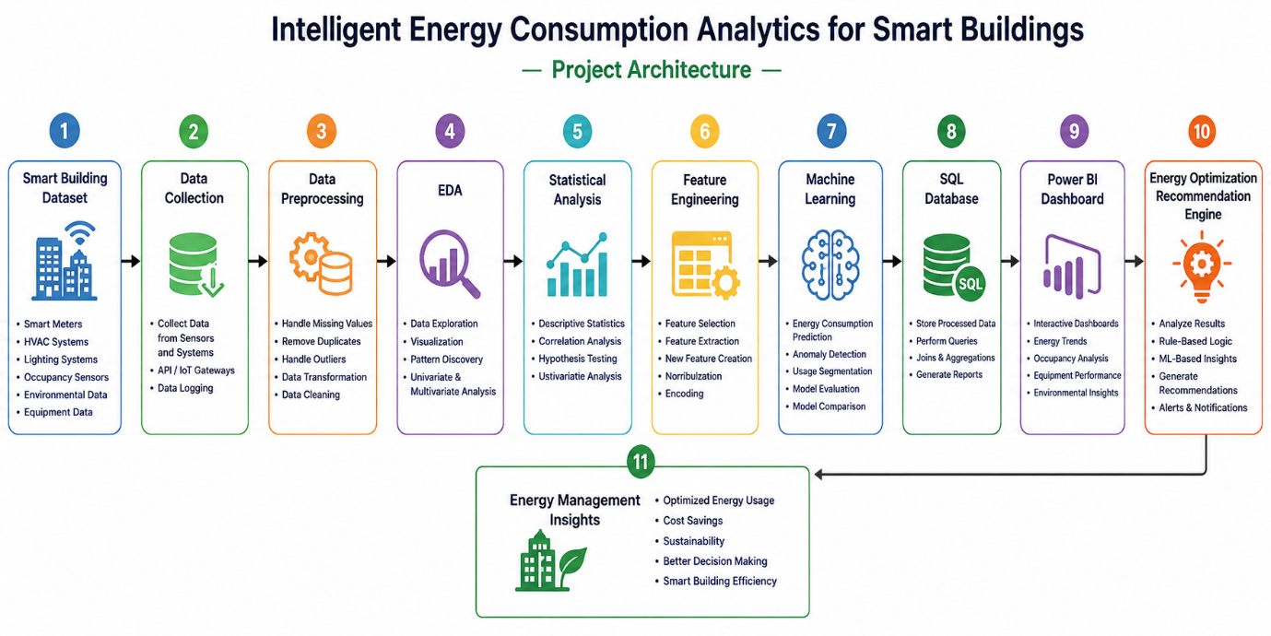

9. Modern Tools (Phase-wise) :
Phase | Tools
Data Collection | Kaggle, Python
Preprocessing | Pandas, NumPy
EDA | Pandas, Matplotlib, Seaborn
Machine Learning | Scikit-learn, XGBoost
Database | MySQL, MySQL Workbench
Dashboard | Power BI
Version Control | Git, GitHub
Documentation | MS Word, PowerPoint
Deployment (Optional) | Streamlit
10. Project Plan :
Phase 1 – Data Collection & Understanding
- Collect Smart Building Energy Dataset
- Understand dataset attributes
- Define project requirements
Phase 2 – Data Preprocessing
- Handle missing values
- Remove duplicates
- Handle outliers
- Data transformation
- Feature engineering
Phase 3 – EDA & Statistical Analysis
- Energy consumption analysis
- Occupancy analysis
- Equipment performance analysis
- Environmental factor analysis
- Correlation analysis
- Statistical analysis
- Matplotlib & Seaborn visualization
Phase 4 – Machine Learning
- Feature selection
- Train-test split
- Model training
- Energy consumption prediction
- Consumption pattern segmentation
- Model evaluation and comparison
Phase 5 – SQL Database
- Store processed data in MySQL
- Perform queries, joins, and aggregations
- Generate analytical reports

Phase 6 – Energy Optimization Recommendation Module
- Analyze ML and analytical results
- Implement Python-based rule/analytical logic
- Generate actionable energy-saving recommendations
Phase 7 – Power BI Dashboard
- Energy Consumption Dashboard
- Occupancy Dashboard
- Equipment Performance Dashboard
- Environmental Analysis Dashboard
- Energy Optimization Recommendations
Phase 8 – Integration & Finalization
- Integrate all modules
- Validate results
- Prepare final report
- Prepare presentation and demonstration
TEAM – 20
2420030296 – K HARINI
2420030297 – V VARSHA
2420030447 – G SHAILAJA

